**Algorithm Analysis Practice Exam. December 2020**

**Student: Pablo Cuesta Sierra**

**Theory Group: 125**

**Practice group: 1251**

1. Check by plotting a histogram that the previous generator follows a linear distribution.

Using exercise1.c to use this function, we get the following histogram: (we can see that the probability increases linearly)

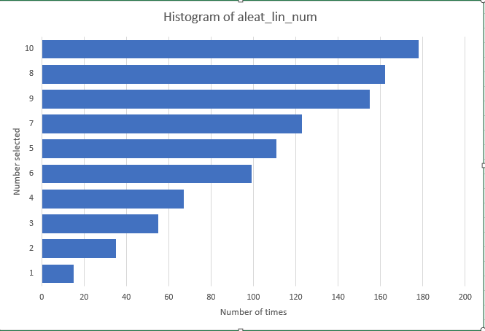

Figure 1

1. Implement bubble sort algorithm.

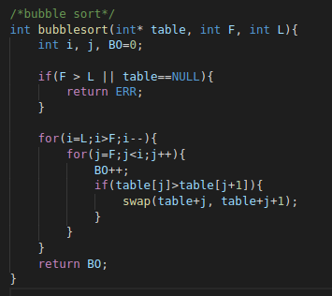

Figure 2

1. Measure and plot in the same figure the BO required to sort (using bubble sort) permutations generated using aleat_lin_num() and aleat_num() to compare the results.

We need to introduce in permutations.c these two new functions, to generate using aleat_lin_num():

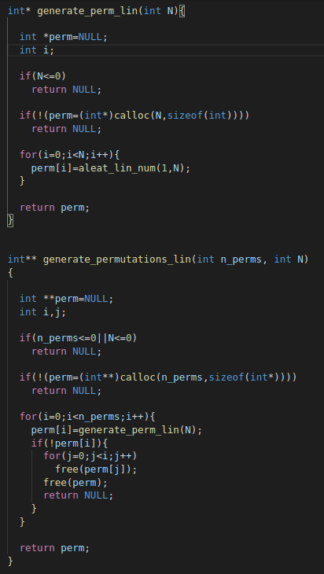

Figure 3

And in average_sorting_times, we have to change generate_permutations() by generate_permutations_lin().

For the experiments I have used the parameters provided (BubbleSort is quite slow, so higher sizes would require a lot of time with my computer).

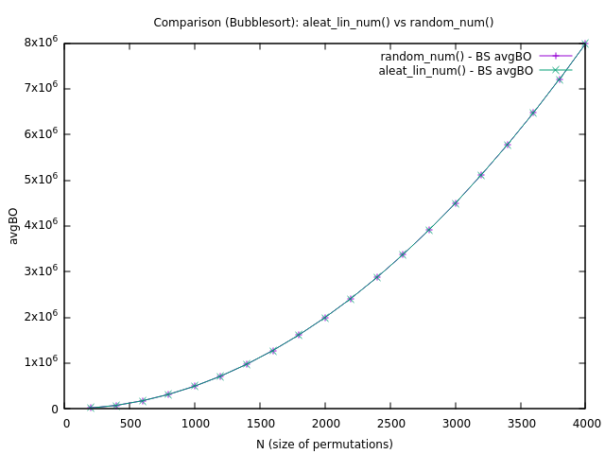

Figure 4

1. Discuss the result.

As we can see, there are no changes between the two different generations. This is because bubble sort performs the same operations regardless of the initial table, it has a cost, for a table of size N, of N(N-1)/2~N²/2. Therefore, the result is exactly the same.